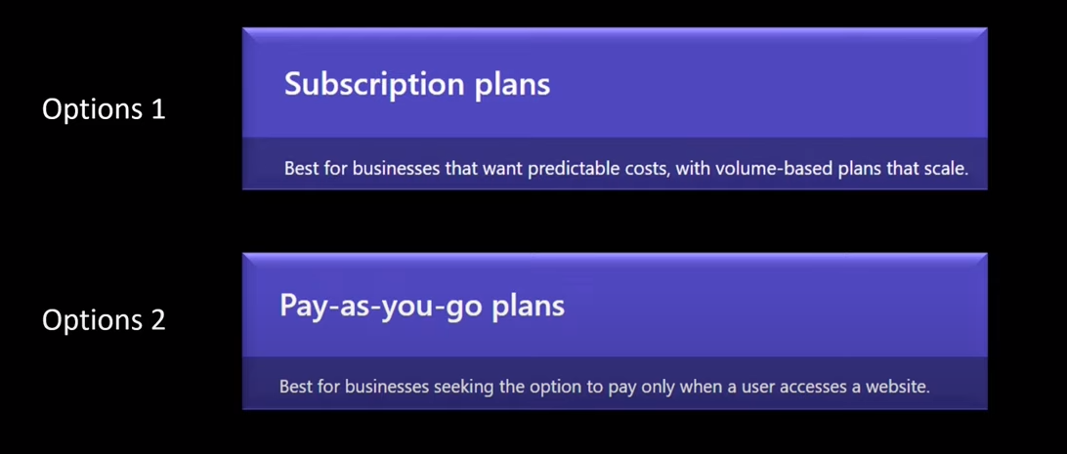

Subscription plan is based on capacity i.e. volume of portal site users

Pay as you go plan best suite if there are predefined users below 10 users count.

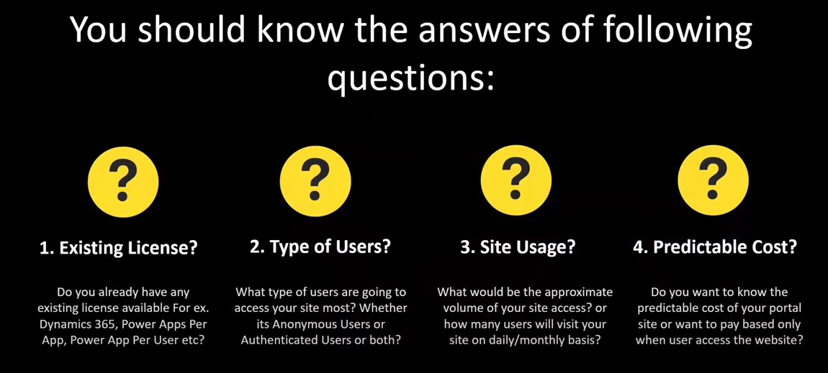

Do you already have an existing license like D365/Power Apps/Power App per User available in your organization? If yes, look at Option 1.

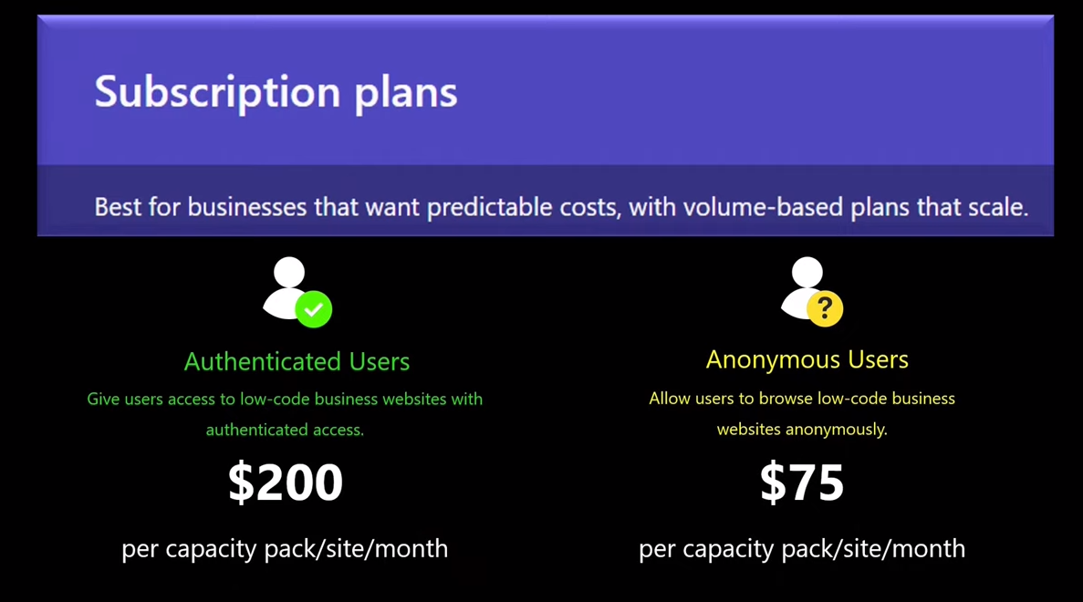

Authenticated users logs in to the website whereas Anonymous users don’t log in.

